**12/3 One-pager**

Ed is always a negative number.

Yes, I also think that the government should monitor the monopoly to ensure that the market can function properly.

**Chapter 13 & 14**

**Outline:**

Monopolistic Competition

* **Monopolistic competition** Market in which firms can enter freely, each producing its own brand or version of a differentiated product.
* no or very low barriers to entry
  + many buyers and many sellers
  + differentiated products that are highly substitutable but not perfect substitutes

Demand Function facing a Monopolistically Competitive Firm

* *Firm’s product is differentiated, there may be close but not perfect substitutes.*
* *If the firm lowers its price a little, it will not steal all customers from competitors.*
* *If the firm raises its price a little, it will not lose all its customers to other firms.*
* The monopolistically competitive firm will face a negatively-sloped, ***relatively elastic demand curve***.

Perfect Competition and Efficiency

* **Productive efficiency** Situation in which a good or service is produced at the lowest possible cost.
* **Allocative efficiency** A state of the economy in which firms produce up to the point where the last unit provides a marginal benefit to consumers equal to the marginal cost of producing it.

What makes a firm successful?

* **Value created relative to competitors due to firm’s ability to**
  + differentiate its product
  + produce it at a lower average cost than competing firms

Oligopoly

* In oligopolistic markets, *the products may or may not be differentiated*.
* *Only a few firms* account for most or all of total production.
* Some or all firms earn substantial profits over the long run because *barriers to entry* make it difficult or impossible for new firms to enter.
* *Examples:* automobiles, steel, aluminum, petrochemicals, electrical equipment, computers

Measures of the extent of competition

* The *concentration ratio* states the fraction of each industry’s sales accounted for by its four largest firms.
  + A 4-firm concentration ratio greater than 40 % indicates that an industry is an oligopoly.
* Herfindahl-Hirschman Index (*HHI*)
  + Sum of squared market shares of all firms:

**HHI = s12 + s22 + . . . .sn2**

* + HHI > 2500 : oligopolistic markets.

Merger Guidelines

* Market definition
  + - *Close substitutes*

Measure of concentration & Merger Standards

* + - *Herfindahl-Hirschman Index (HHI)*

Equilibrium in an Oligopolistic Market

* When a market is in equilibrium, firms are doing the best they can and have no reason to change their price or output.

Equilibrium in oligopoly markets:

**Nash equilibrium (NE)** Set of strategies or actions in which each firm does the best it can given its competitors’ actions.

* no or very low barriers to entry

Can make sure there are enough companies in the market to compete.

* many buyers and many sellers

Buyers also need a certain number, if there are three companies, there are two buyers, and these two buyers become loyal customers of one company, then the remaining two companies can't sell their products.

* differentiated products that are highly substitutable but not perfect substitutes

This also ensures that the product will not be monopolized, because there will always be alternatives.

When we talk about efficiency and Allocative efficiency，can provide Perfect Competition and efficiency.

* + differentiate its product

If a competitor makes a copy of the same product, it will not sell very well unless it is modified

* + produce it at a lower average cost than competing firms

It is also a good idea to be able to produce products that are cheaper than competitors' and can be sold at a lower market price

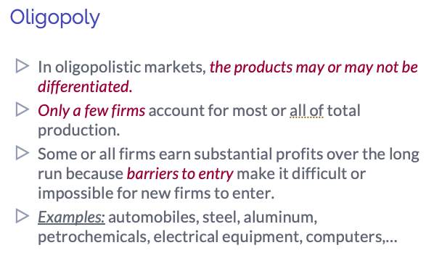

My understanding of Oligopoly is that it is a monopoly due to the difficulty of new entrants in some of the more expensive, technologically demanding, or state-controlled market segments.



